Rei Kawakubo Bildbeispiele für die Gruppenarbeit
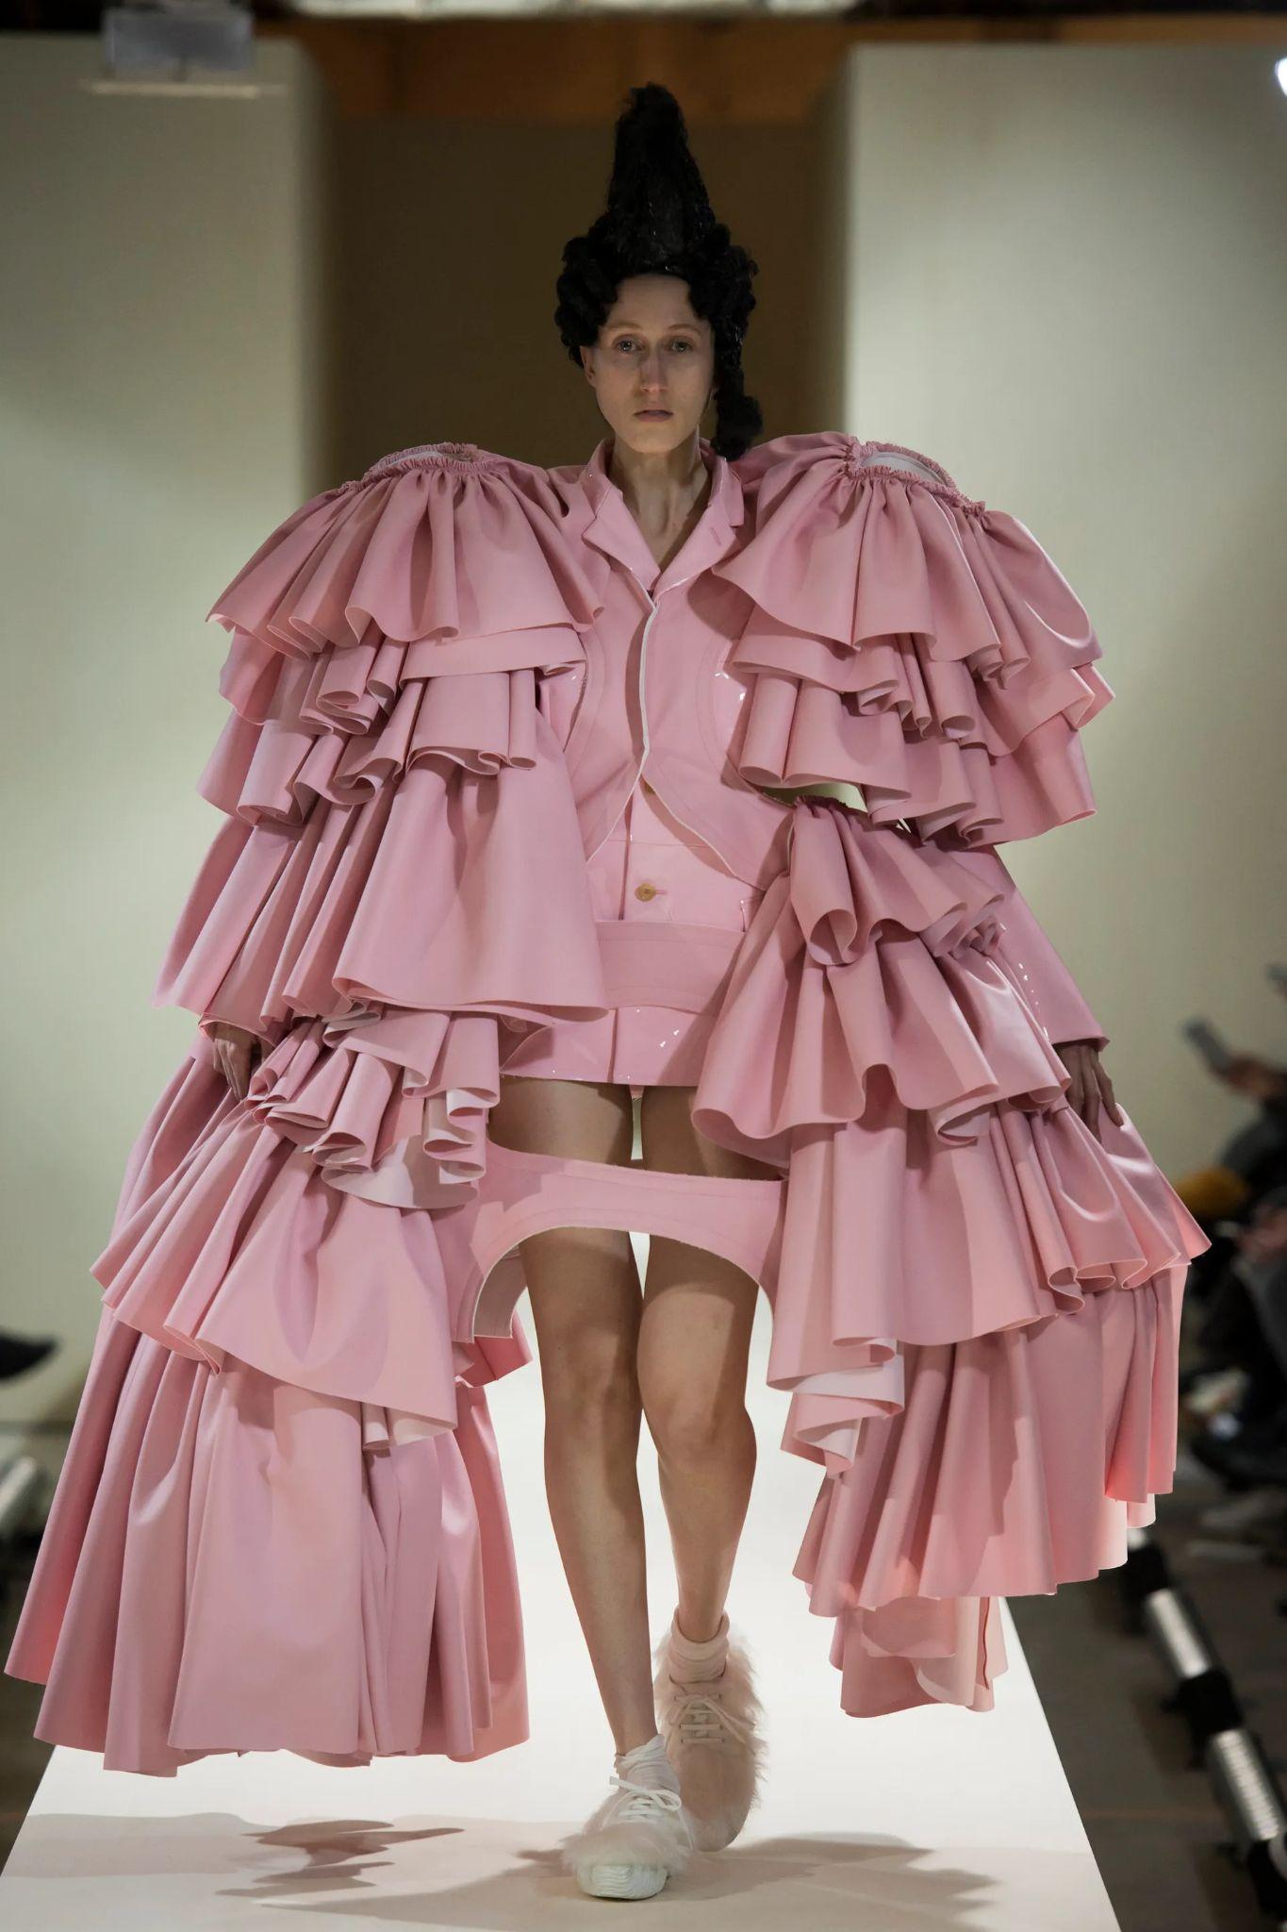  Abb. 1 | 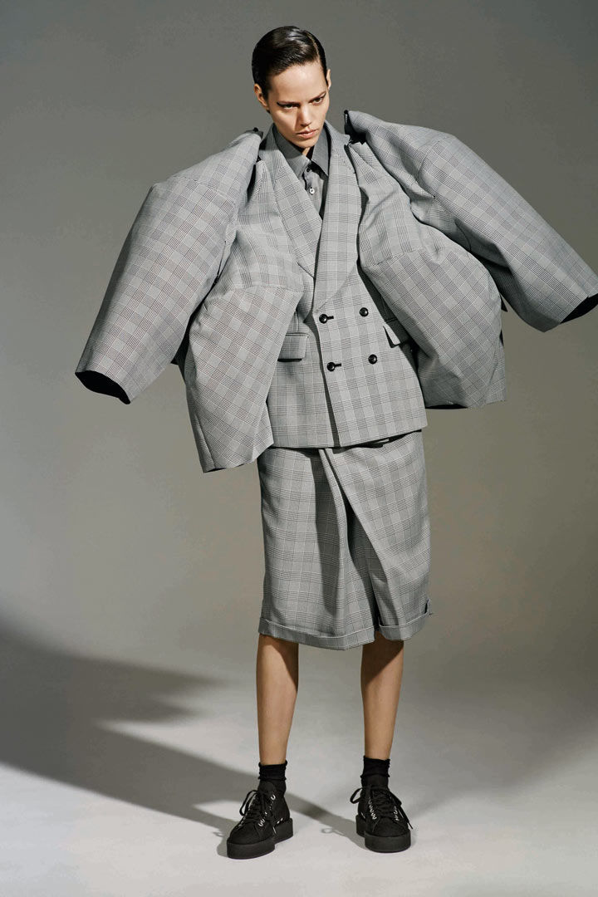  Abb. 2
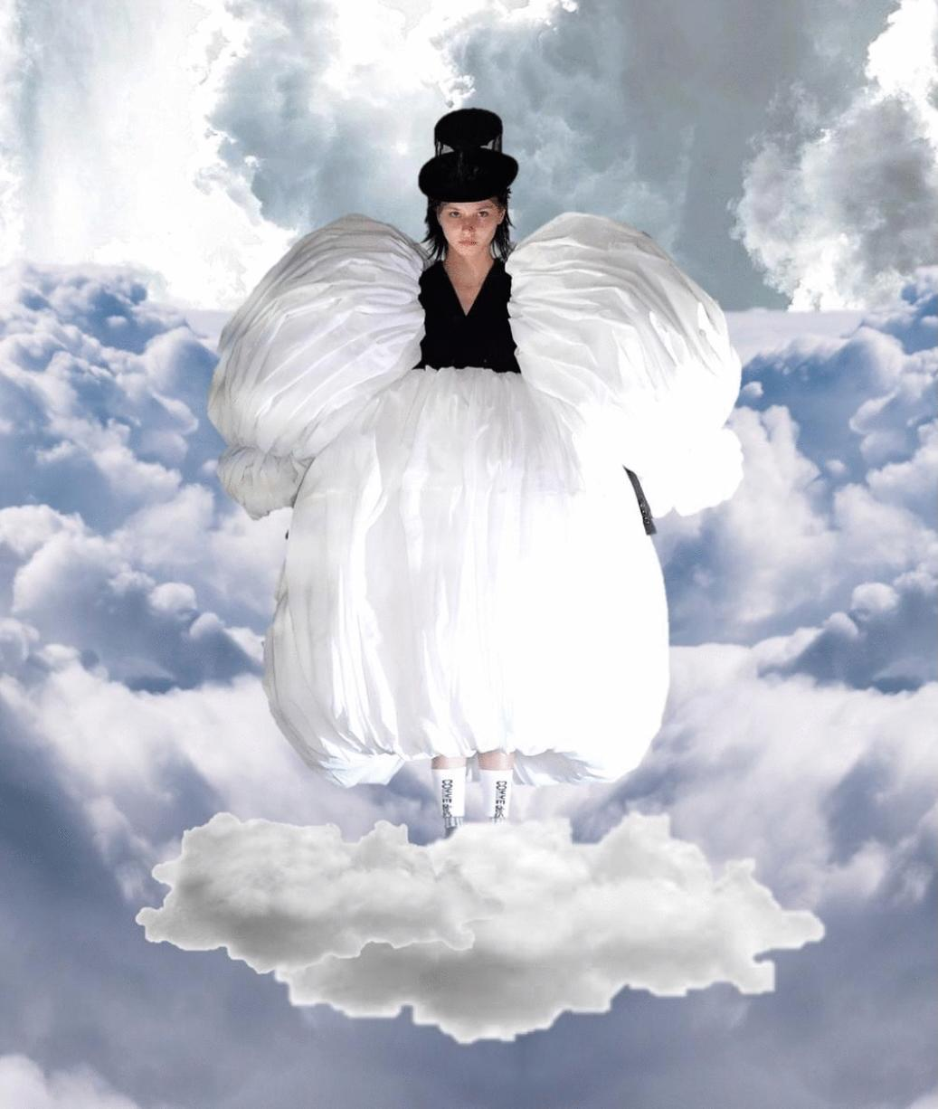  Abb. 3 | Links  Abb. 1: https://www.vogue.com/fashion-shows/fall-2016-ready-to-wear/comme-des-garcons/slideshow/collection#17  Abb. 2: https://www.metmuseum.org/exhibitions/listings/2017/rei-kawakubo/select-images  Abb. 3:  https://designandculturebyed.com/2021/03/24/monochrome-serenity-comme-des-garcons-aw21/

